Vishal Patel (12845885), Karandeep Chana & Matthew Strudwick

University of Brighton

Game Report

CI328 – Assessment 2, Game Design and Implementation

**Game Summary**

Overview

Our game is called ‘The Hunting’. It’s a game of the action genre. It’s a network multiplayer game where each player controls a spaceship. The spaceship is able to fire laser bullets. The main aim of the game is to eliminate enemy spaceships until one spaceship remains. The player who controls that spaceship wins. We used Adobe Flash Professional and SmartFoxServer to create our game.

Objectives

* Choose a spaceship from a selection of four.
* Control the multi-directional moving spaceship using Arrow keys.
* Destroy enemy players via a firing system using Spacebar key.
* Maintain your health bar above 0.
* Survive until you’re the last player remaining.

Rules

* You must select your spaceship before you start the game, once selected you cannot change until that round is over.
* The spaceship can be moved 360 degrees. However it can’t go off the bounds of the map.
* Laser bullet ammunition is unlimited, hence every player can fire an unlimited amount of laser bullets.
* A minimum of two players are required for the game to begin.
* Each round will end, either if one player is remaining having eliminated all other players, or if all players but one have left the game, thus leaving that last remaining player the winner.

Gameplay

A player is spawned in a random location on the map. They will have full health, three bars. Immediately they may or may not see enemies, they must navigate around the map looking for enemies. Once they find them, they will begin firing laser bullets to kill them. When a player is killed they’re faced with a game over screen asking them to either spectate the game or exit. If they spectate they will watch the remaining players. When the winning player kills the final opponent, they are faced with a game over screen as well. However the game over screen will have their score. The spectate button will become inactive.

**Screen/Level Map**

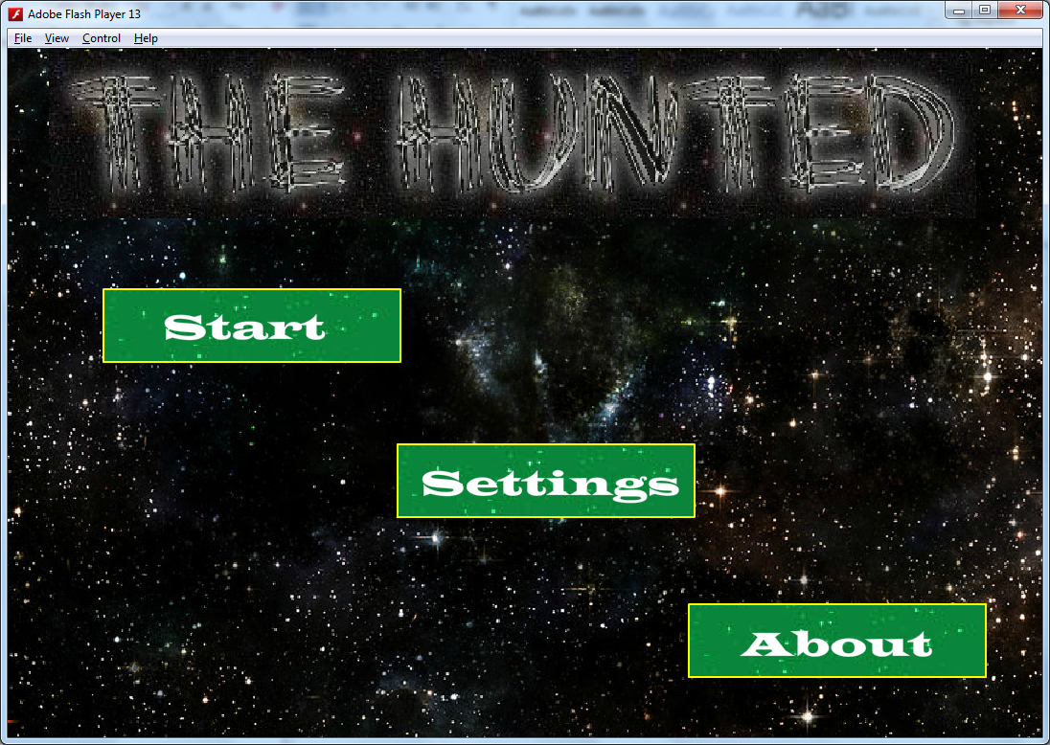

Buttons

Here is the first screen, which is shown, when the game is first started, The MenuScreen. Pressing any of the buttons directs to the respective screen.

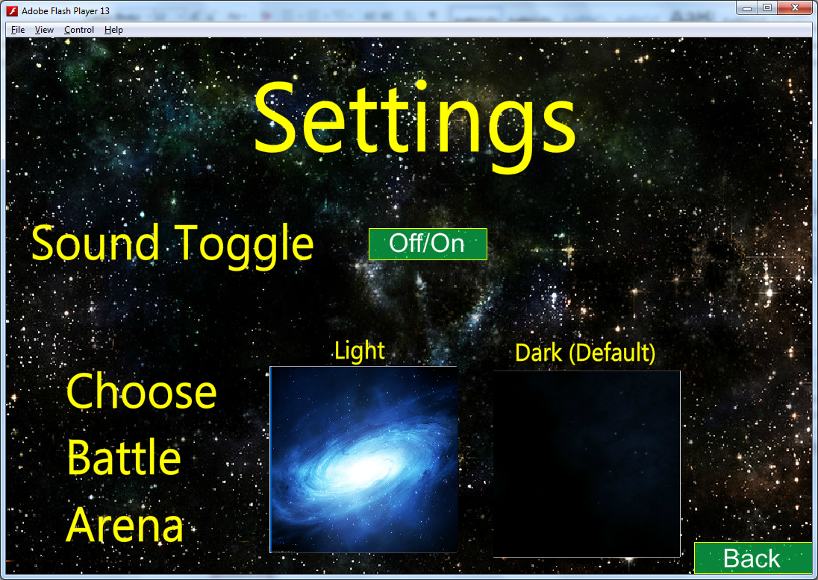

If the Settings button is pressed on the MenuScreen, the SettingsScreen is displayed. Here settings about the game can be altered. The Back button goes back to the MenuScreen.

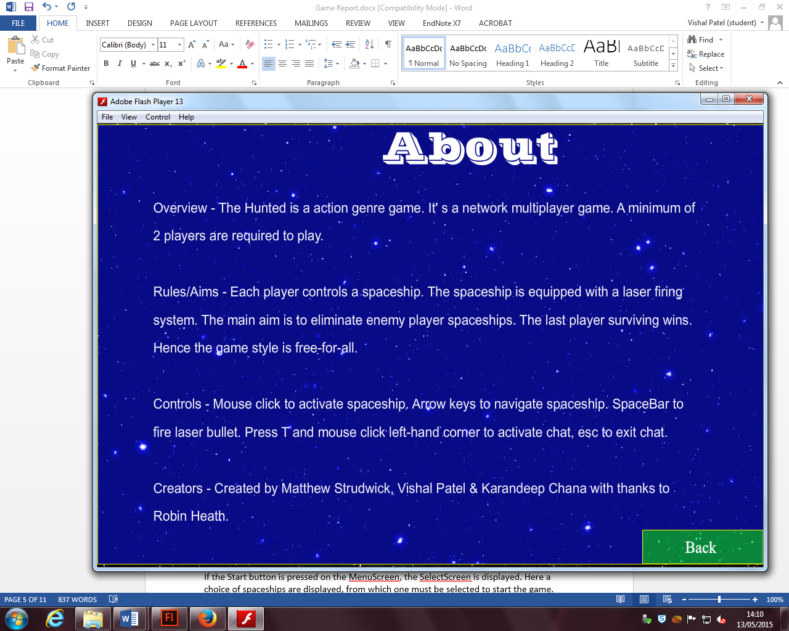

If the About button is pressed on the MenuScreen, the AboutScreen is displayed. Here information about the game is displayed. The Back button goes back to the MenuScreen.

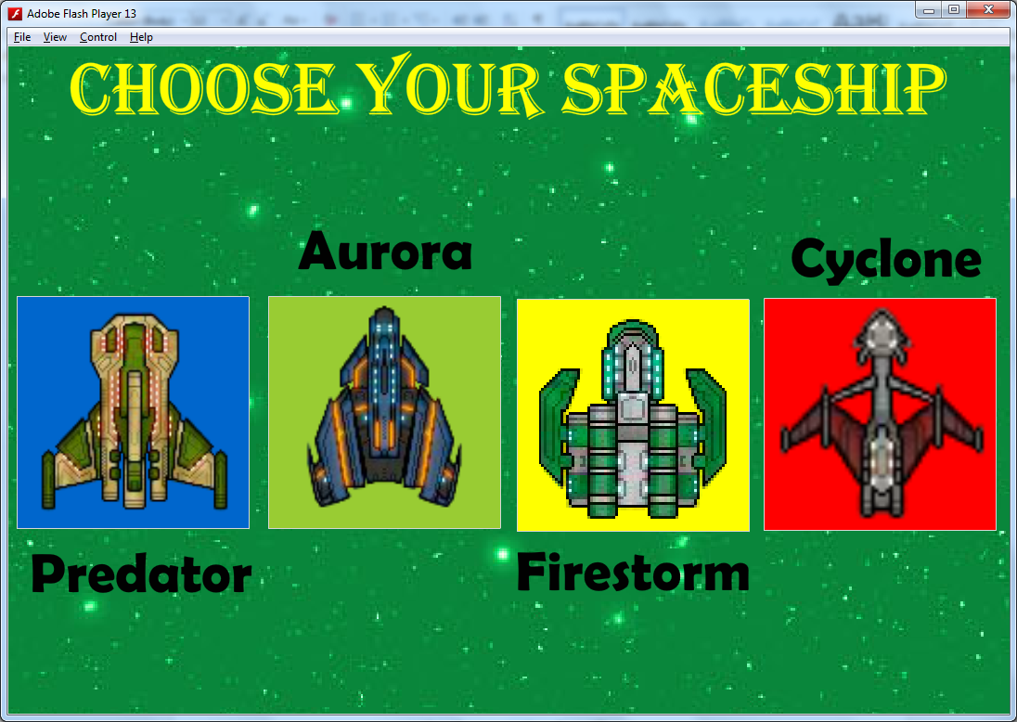

If the Start button is pressed on the MenuScreen, the SelectScreen is displayed. Here a choice of spaceships are displayed, from which one must be selected to start the game.

**Network Utilization**

Network Architecture

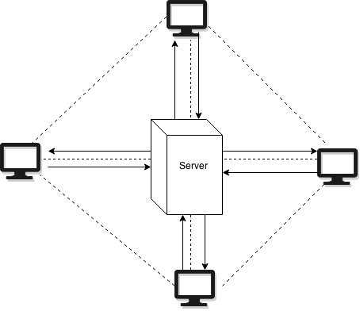

Component Interactions

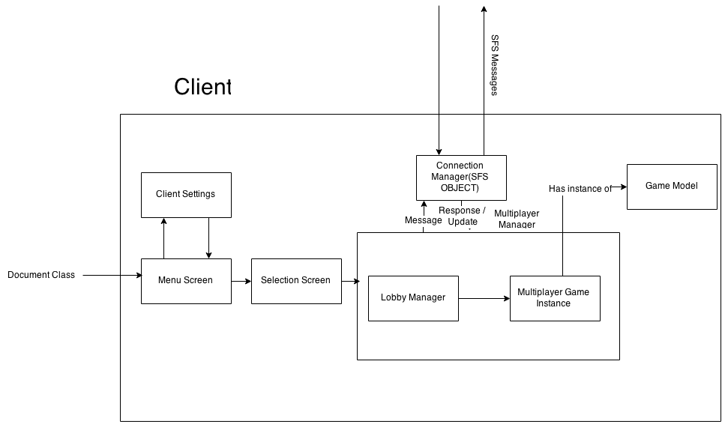

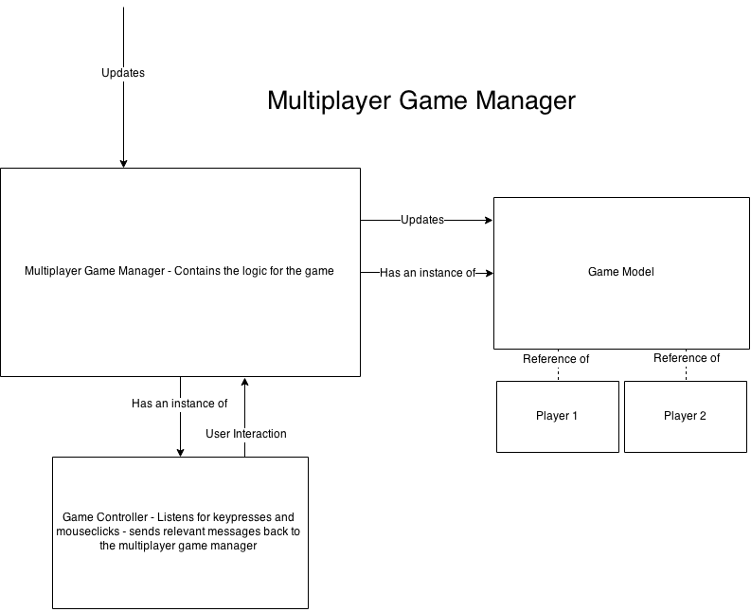

**Implementation Specification**

**Clients**

Objects

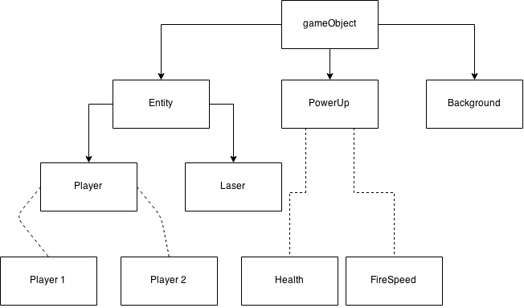

Code Structure

Assets

**Buttons:**

SpaceButton - This is the main button which we use throughout the game. This buttons were created in Adobe Photoshop. Variants of this button were made to take different button actions e.g. rollover.

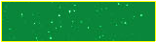

Ships – We created four different buttons to represent the four different spaceships that can be chosen for the game. The buttons were created in Adobe Flash Professional, with the images on the buttons, of the ships, coming from the internet.

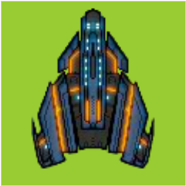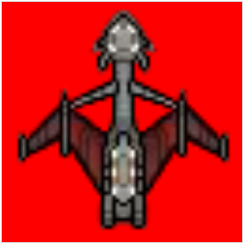 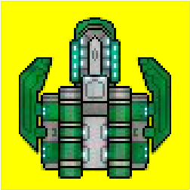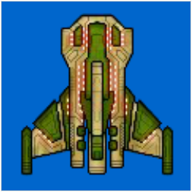

Maps – These buttons are made up of images from which are the maps used in the game. The two buttons are called light and dark respectively. The buttons were created in Adobe Flash Professional, with the images on the buttons, of the maps, coming from the internet.

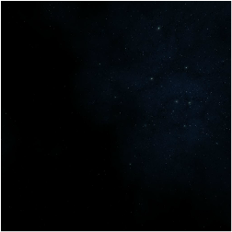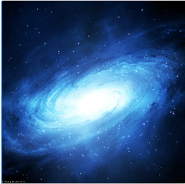

**Images:**

Spaceships – We used four images for four different spaceships. The images are from the internet.

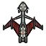 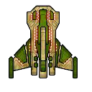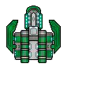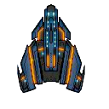

Beams – This is the main image from which we cropped four different colour images. Those four images were then used as the laser bullet objects, which the spaceship fires. The image is from the internet.

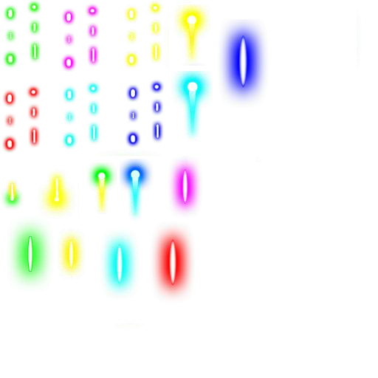

Title – This image is the title image which is used on the menu screen. The image was created using an online custom font text generator.

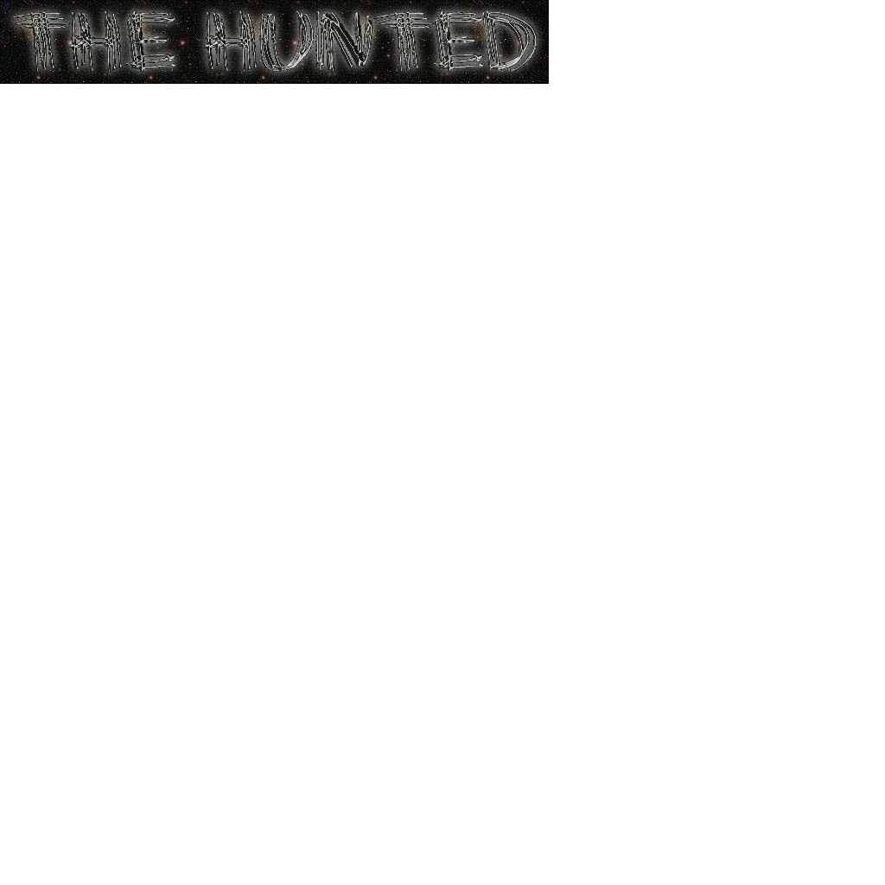

MenuScreen Background – This image is a space themed image which is displayed on the menu screen. The image is from the internet.

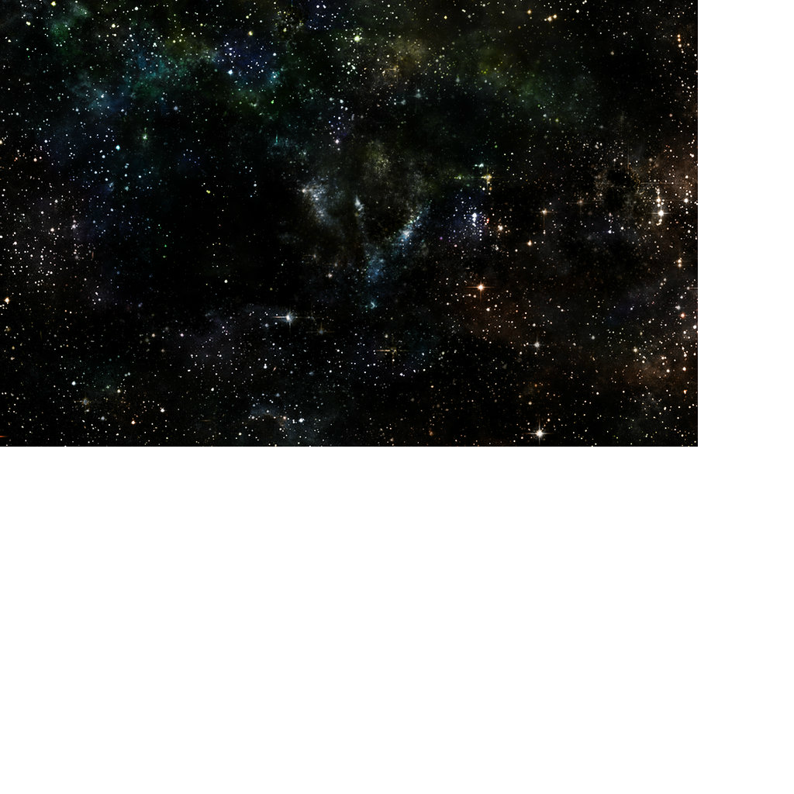

Light Map Background – This image is a blue colour space themed image which is one of the two game maps. The image is from the internet.

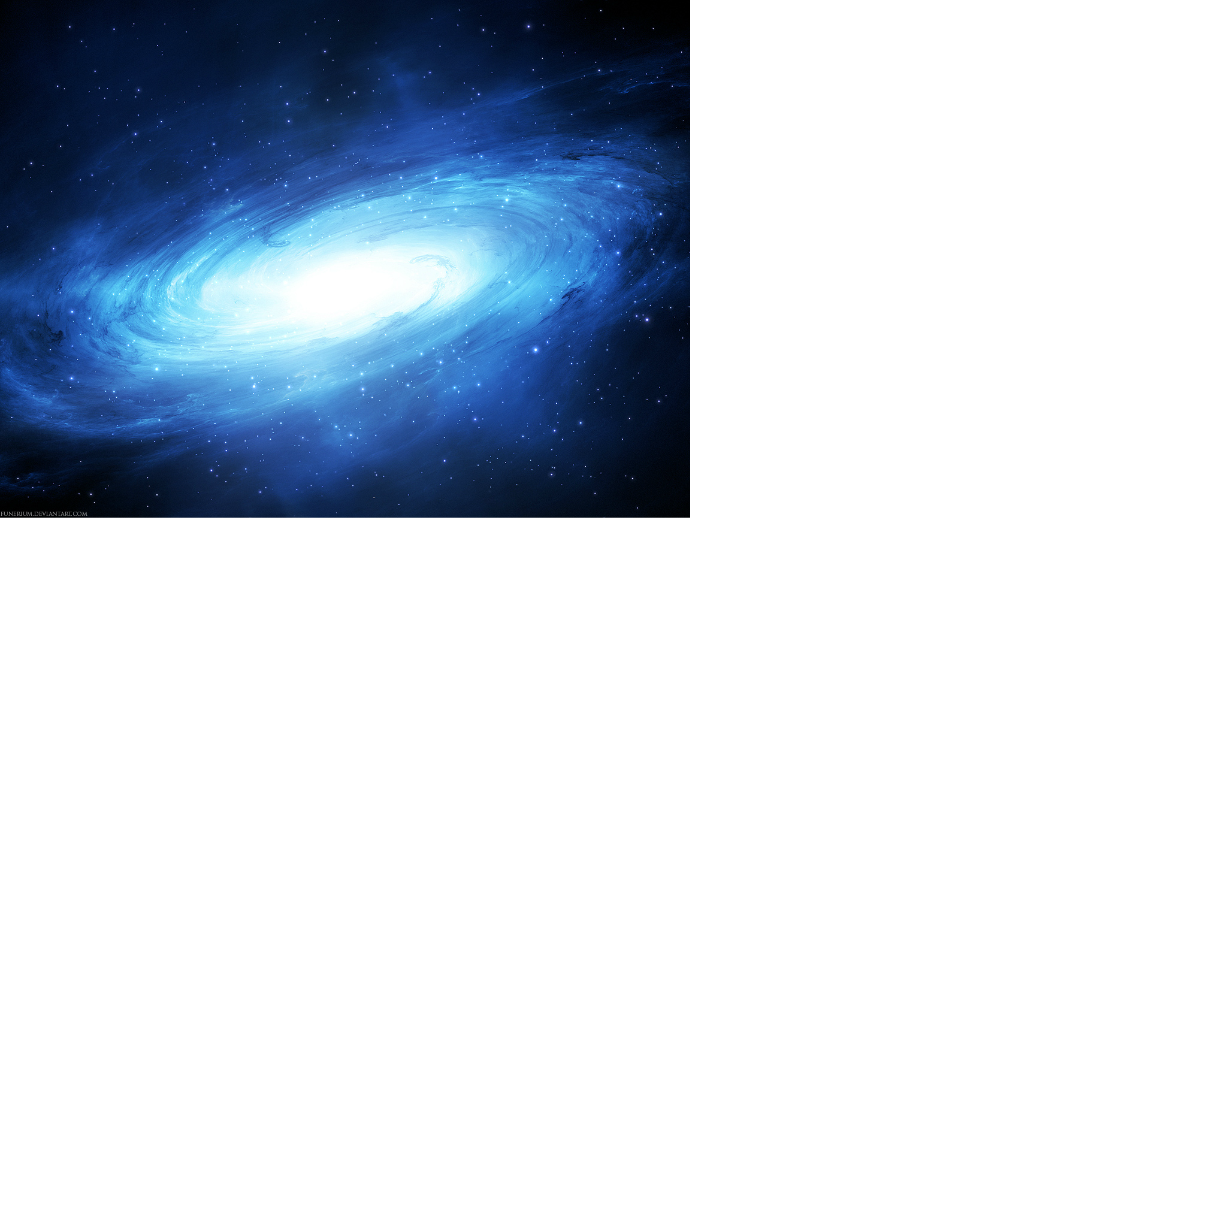

Dark Map Background – This image is a black colour space themed image which is the other of the two game maps. The image is from the internet.



Screen Backgrounds – We created two different colour images to use as the background on various movieclips. This images were created in Adobe Photoshop.

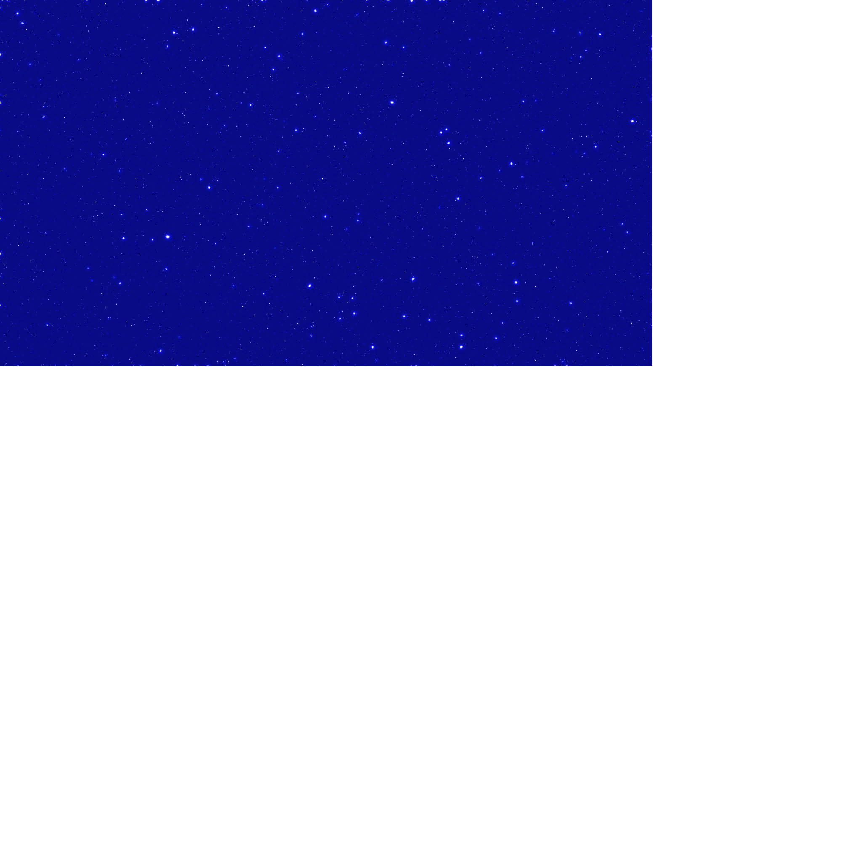 

**Sounds:**

Theme – We created our own theme music for our game. The theme was created using Logic Pro X.

Laser Sounds – We also created laser sounds which are used throughout the game. These sounds were also created using Logic Pro X.

**Server**

Data Structures

Code Structure

**Implementation Evaluation**

**References**

Space-Star Background (Website) - <http://fantmayo.deviantart.com/art/Stars-Background-211786850>

Light Space Background (Website) - Reference - <http://wallpaper-kid.com/cool-space-background-blue.htm>

The Hunted Custom Font Title (Website) - <http://www.cooltext.com>

**Appendix 1:** **Game Concept Presentation**

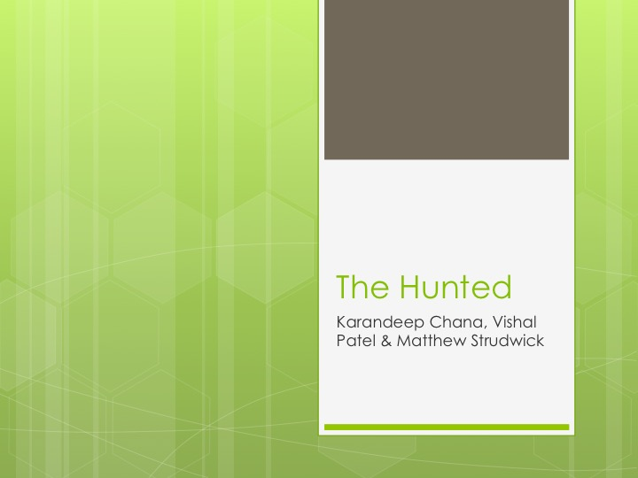

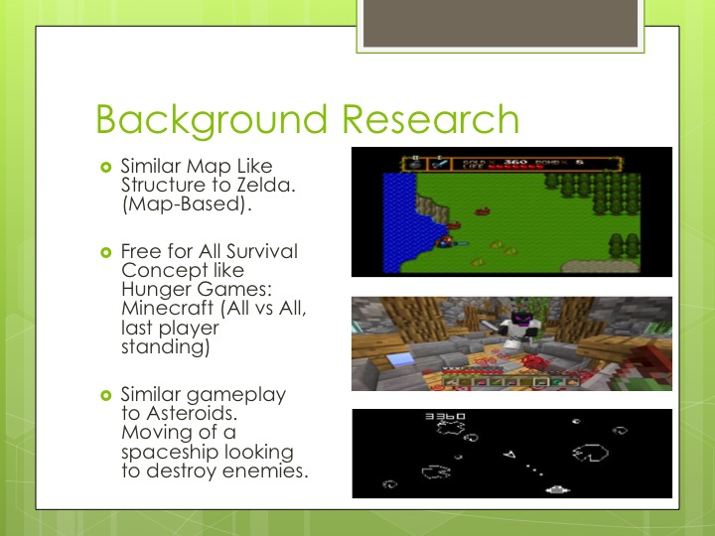

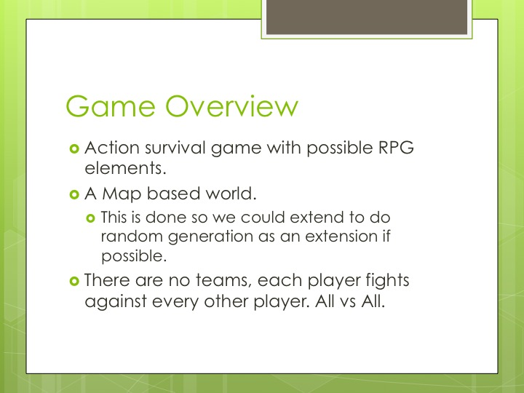

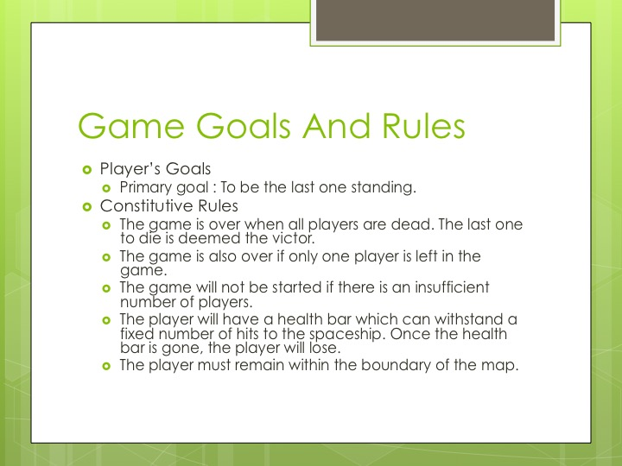

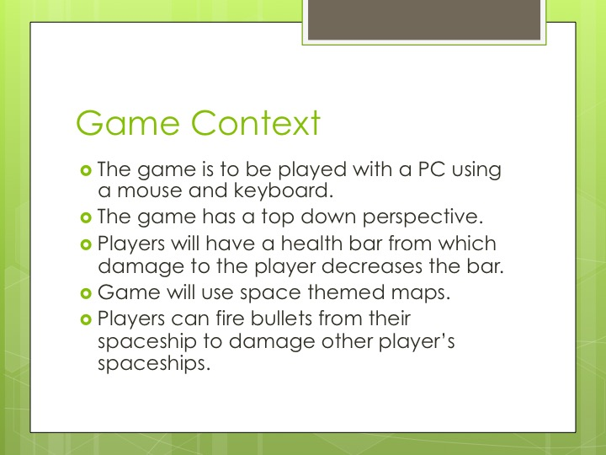

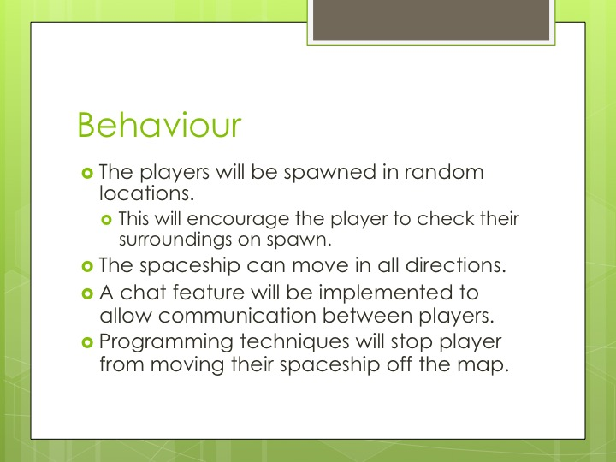

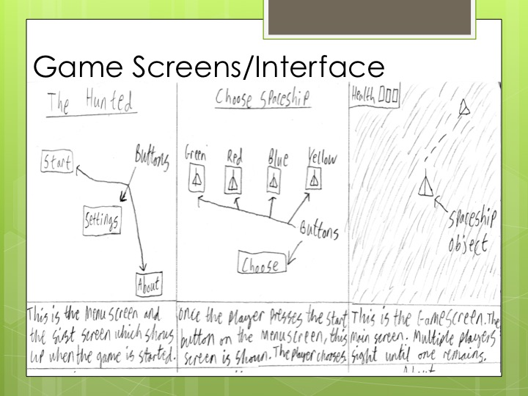

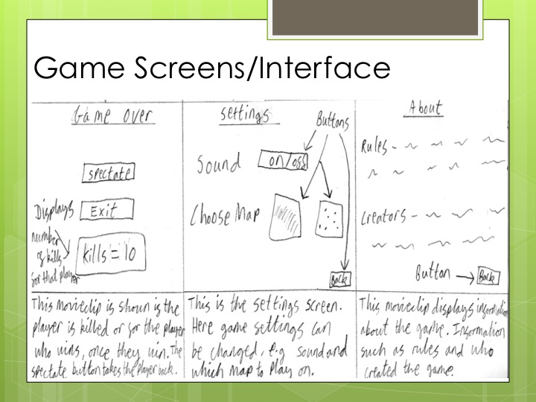



**Appendix 2:** **Extra Information**